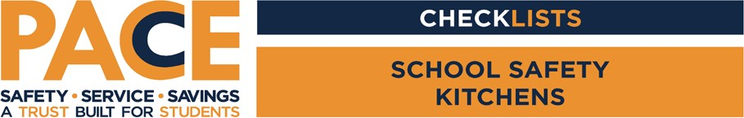

Person(s) Conducting the Survey:

Location:

Date:

|  |  |  |
| --- | --- | --- |
| Condition |  | Recommendation/Additional Info |
| Is auxiliary lighting (battery backup) provided in the event of a power failure? | Yes No |  |
| Are deep fat fryers in use and operating properly? | Yes No |  |
| Are the proper fire suppression systems in place and inspected? | Yes No |  |
| Are exhaust hoods equipped with grease extracting filters and  cleaned regularly? | Yes No |  |
| Are ovens/warmers and refrigeration kept at the proper temperature? | Yes No |  |
| Are there spill and cleaning procedures for floor care  and safety? | Yes No |  |
| Do areas in the kitchen that can become wet and slippery have appropriate anti-slip flooring? | Yes No |  |
| Are the cafeteria tables open and close appropriately? | Yes No |  |
| Do the cafeteria tables latch when folded? | Yes No |  |
| Are the facilities clean and  sanitary? | Yes No |  |
| Are roll up doors tested during fire inspections? | Yes No |  |

1