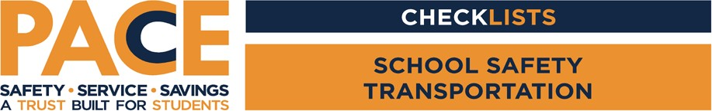

Person(s) Conducting the Survey:

Location:

Date:

|  |  |  |
| --- | --- | --- |
| Condition |  | Recommendation/Additional Info |
| Is an appropriate training  program in place? | Yes No |  |
| Is a scheduled maintenance program in place? | Yes No |  |
| Are vehicles stored on the  property and not taken home? | Yes No |  |
| Is proper recording of pre- and post-trip inspections done? | Yes No |  |
| Are two-way radios used on the buses? | Yes No |  |
| Are all CDL procedures  following? | Yes No |  |
| Do you follow the ODE Pupil Transportation manual? | Yes No |  |
| Do your special education drivers follow IEP recommendations? | Yes No |  |
| Do you conduct the  required annual evacuation drills? | Yes No |  |

1